ENG503 Final term compiled by Shahnawaz Ch

ENG 503
Easy paper
Define motivation..
Define corpus...
Concept of english language teaching...
Creole and pidgin difference...
Role of tutor or teacher..
Eight types of writing or discuss preparing writing..
Incubation discuss..

503
Types of implicature
Dialect
Cultural intelligence
Names of formative motivation
Remembering words kia five types
Historical factors
Types of language leaning three names
Baqi yad nahi

503... 5pm... 8th Sep
Mcqs were Easy..
SUBJECTIVE
1.sociolinguistics define
2.Narrative point of view
3. Deductive Approach
4. Presupposition and entailment
5. Characteristics of a teacher
6. Six factors that are cause for research in ELT
7. Cultural intelligibility
8. Three strategies for ELT
503
types of implicatire
conversational analysis
characteristics of CDA
different things learners need to kno about word
concept of ELT
note on free verse
factors for good teaching

ENG503 08.09.2018 11:00am
#Subjective was easy
1. Detail note on major types pf reference 5marks
3. Additutive factors 5 marks
3. Five advantages of CALL
4. VAN 2009 six points to English language teaching 5 marks
5. Define "word stress" 3 marks
6.three uses of skype 3marks
7. What is Proficient level in language teaching 3marks
8. What is English language teaching 3 marks
9. Write two non instructional material types
10. Two types to enhance vocabulary
11. Parallel corpus
12. Situational factors
#Objective was also almost easy. About 15 questions repeated Objective
New mcqs
1. Old technique to enhance vocabulary
Will update more if reminded

Paper :503
Define sociolinguistics?
Name two motivation factors?
Name six strategies for Classroom..shyd aisa koi question tha mujay sahi say yad nhi..
Why grammar is not reached through text motivation?? 5 disadvantage of grammar translation method? Define frequency and range ?define six strategies for classroom management? Define teachers role as assessor? Bs shyd itny he questions thay..

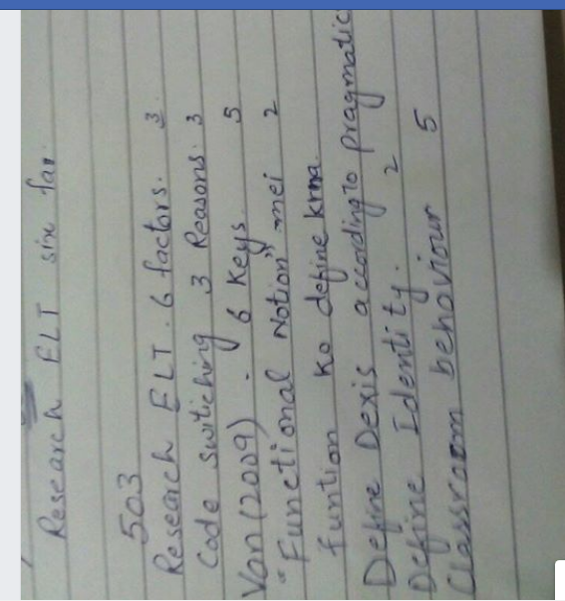

Unexpected attempt for 503!!!!!
Bohat bura hua , aik mcqz b mera koi repeated nhi tha ,sb new unseen..
Subject tough!
Mentioned topics are below!
1.South asian english,
2.Dialect
3.Monolingual corporus
4.Cultural intelligence
5.Research definition by macmilan & schumaker
6.Teaching
7.Curriculum development
8.Dervin definition ---------?
Others out of mind..

